[NOTE-To host your Java Web Application on AWS using Elastic Beanstalk service, you need the **.war** file of your application. Keep the .war file ready]

How to Create AWS Account? Click –

[**AWS - Account Creation.pdf**](https://drive.google.com/open?id=1eFMi_RyNu7N8L4Mk5DnafJafr8sVWd5d)

1. Login to AWS Management Console

* Go To -  
   <https://aws.amazon.com/>
* Click on “**Sign In to the Console**” button.

**OR**

Hover the mouse pointer to “**My Account**” drop down menu and click on “**AWS Management Console**”

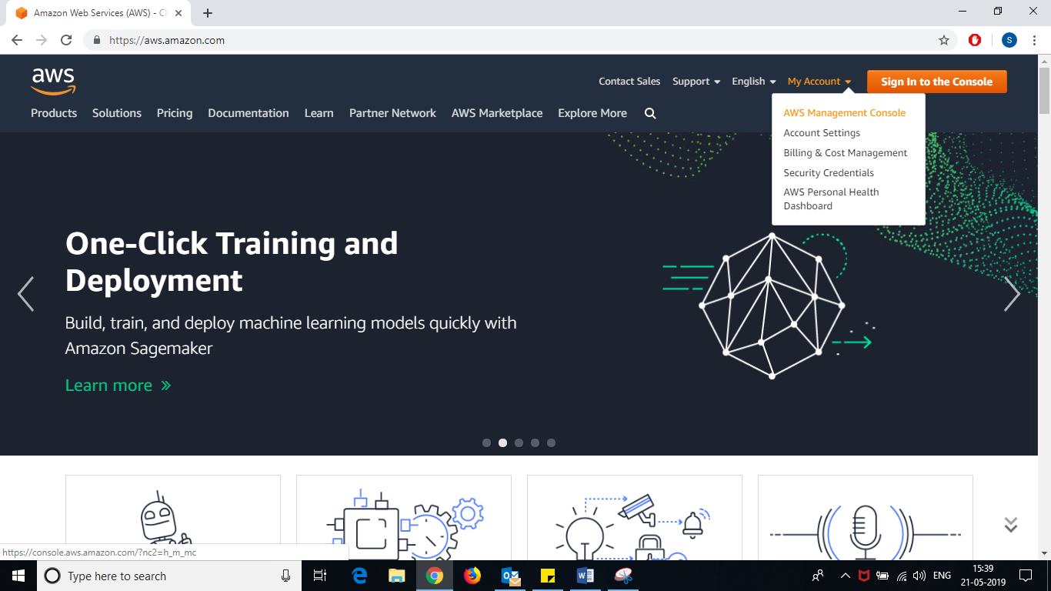

* Enter **Email Id**
* Click on “Next” button

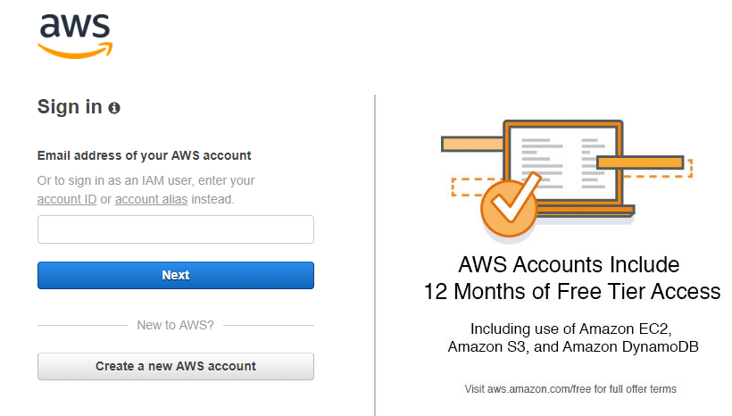

Enter your **email id** used to create AWS account.

* Enter your password
* Click on “**Sign in**” button.

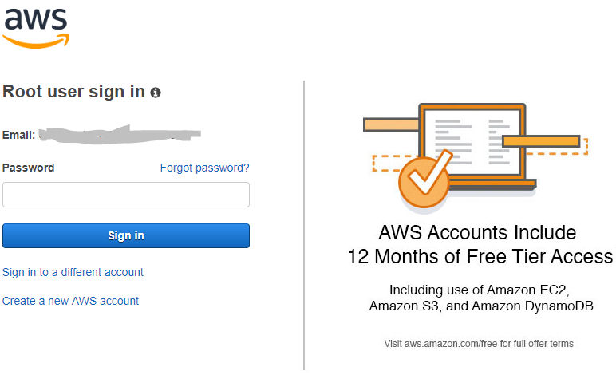

1. On the top right corner (next to your AWS Account Name), **change the region (location)** to “**Asia Pacific (Mumbai)**”

* Hover mouse to Ohio or whatever location it shows (next to your AWS Account Name).
* Select “**Asia Pacific (Mumbai)**” from the drop down list.

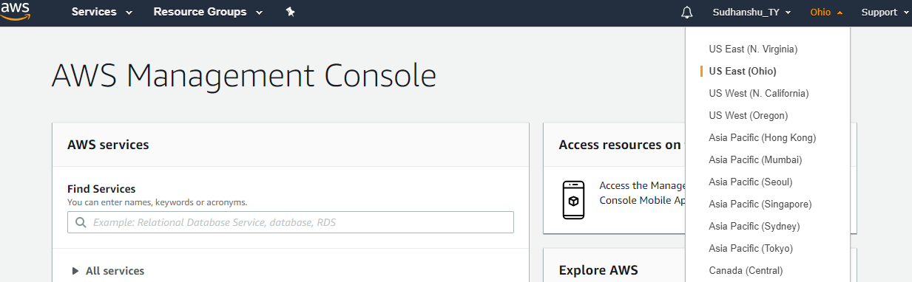

1. Expand “**All services**” 🡪 under ***‘Compute’*** select “**Elastic Beanstalk**”.

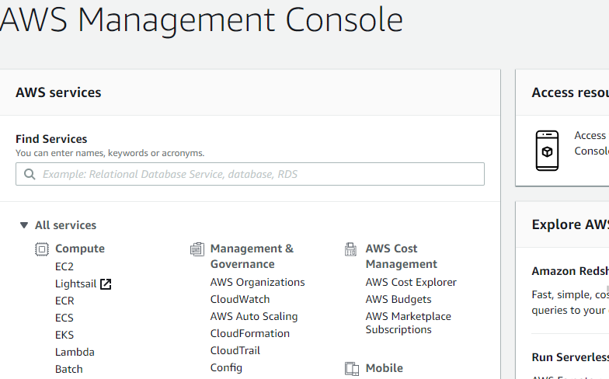

1. Click on “**Launch Instance**” button.

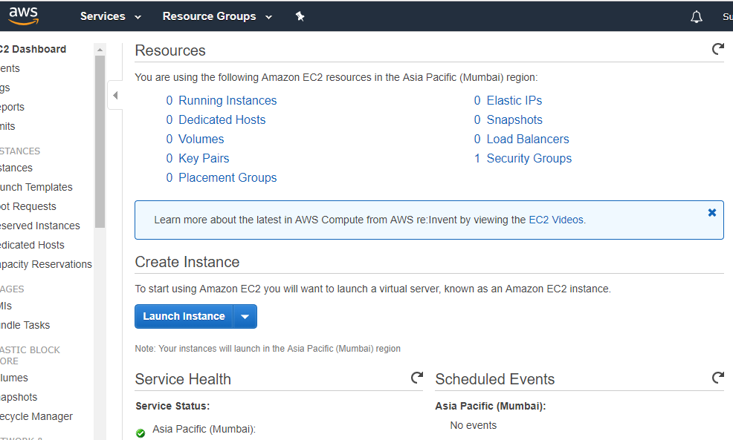

1. Check the “**Free tier only**” checkbox

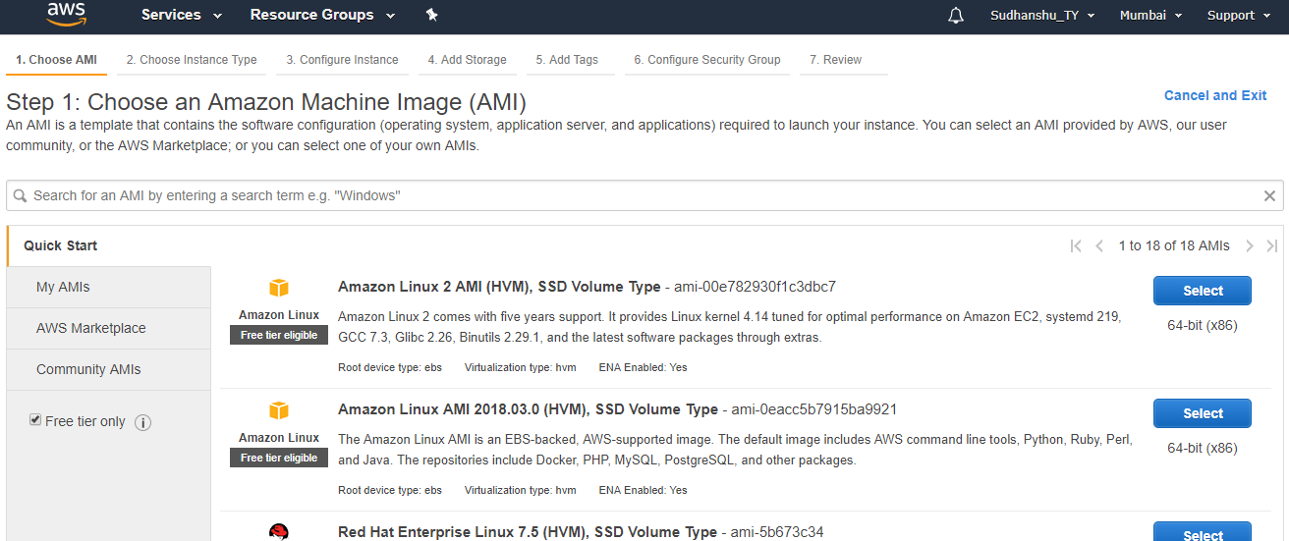

1. Scroll down and click on “**Select**” button against “**Ubuntu Server**”. (ensure that it is eligible for Free Tier if you have not checked the ‘free tier only’ checkbox in previous step).

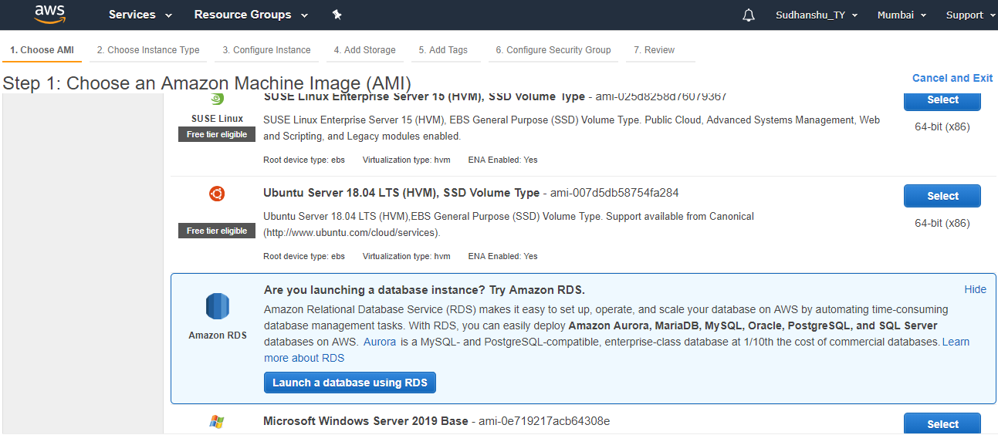

1. Select the instance type “**t2.micro” (free tier eligible)** and click on “**Next: Configure Instance Details**” button –

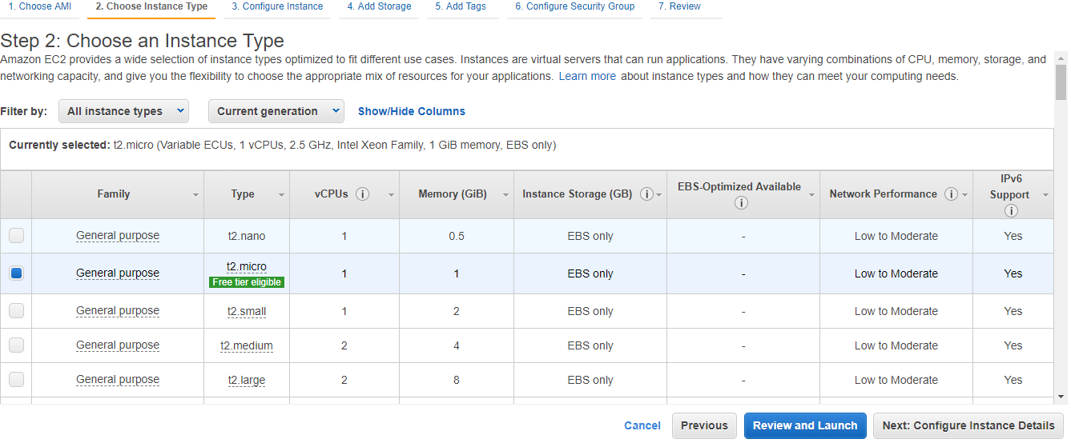

1. On the ‘Configure Instance’ page keep the default configuration. Click on “**Next: Add Storage**” button –

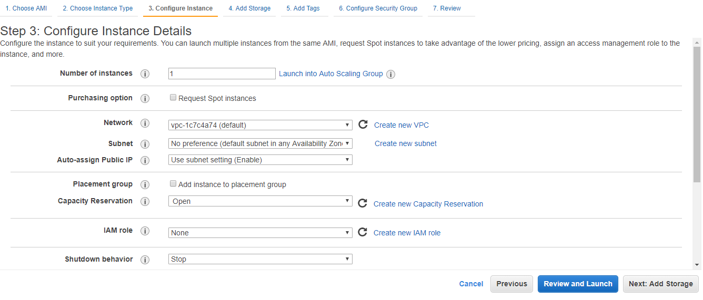

1. On the ‘Add Storage’ page –

* **Size(GiB)** : **8** or **10** (must be less than free tier eligible size ( **<= 30** )
* **Volume Type : General Purpose SSD (gp2)**
* Click on “**Next: Add Tags**” button

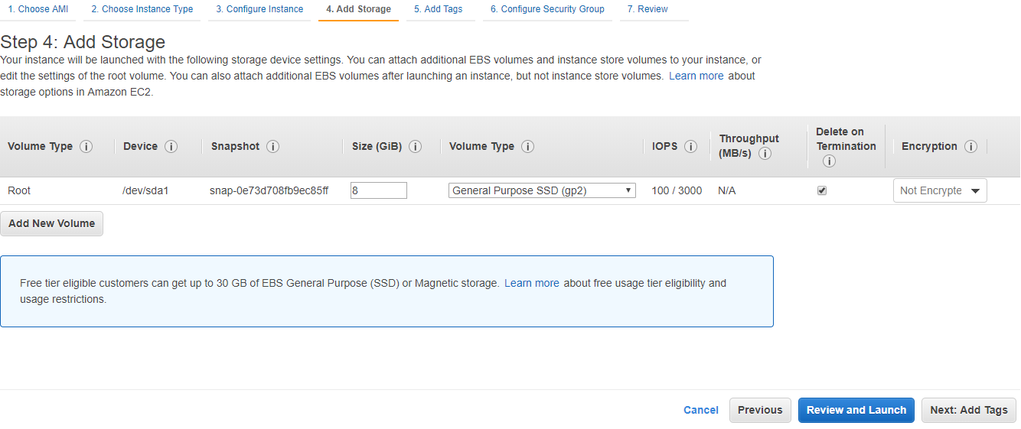

Check free tier eligible max size and Volume type here.

1. On ‘Add Tags’ page click on “**Add Tag**” button –

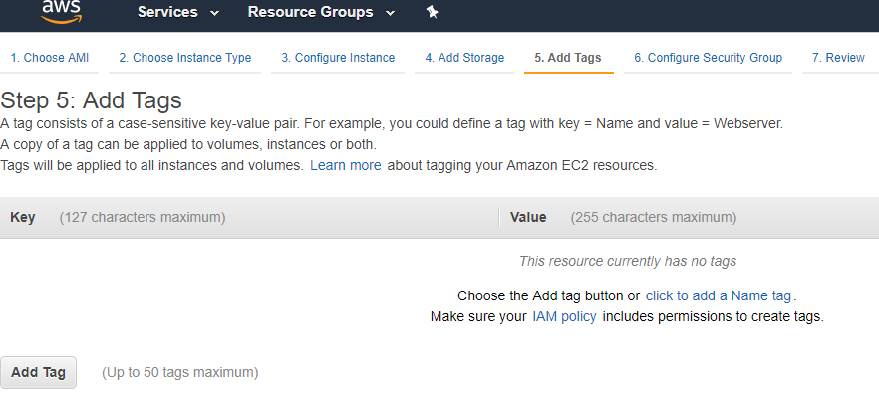

1. On the ‘Add Tags’ page, Enter the key and value (case sensitive) –

* **Key : name**
* **Value : webserver_ubuntu**
* Check “Instances” & “Volumes” checkboxes.
* Click on “**Next: Configure Security Group**” button.

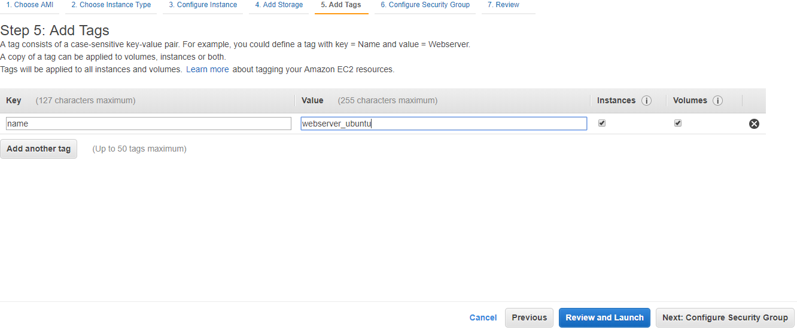

1. On “Configure **Security Group**”

* Select “Create a **new** security group” radio button, then
* click on “Add Rule” button –

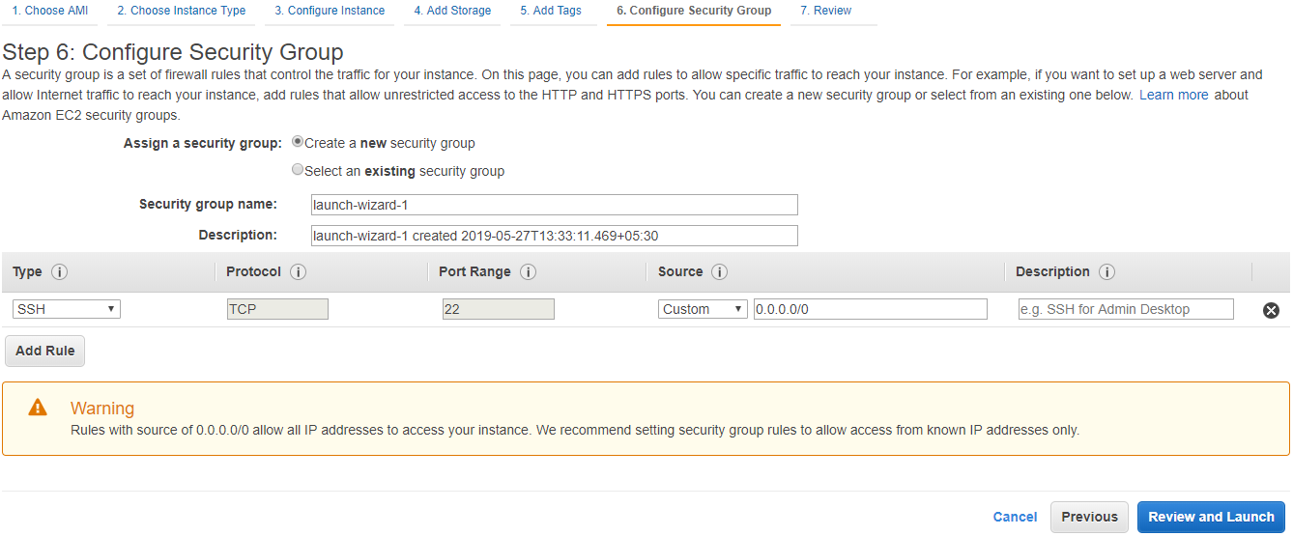

1. Add the following protocols –

**Type Source**

* SSH Anywhere (--> required to connect to instance using PuTTY)
* All TCP Anywhere
* All UDP Anywhere
* RDP Anywhere
* All Traffic Anywhere
* HTTP Anywhere
* HTTPS Anywhere

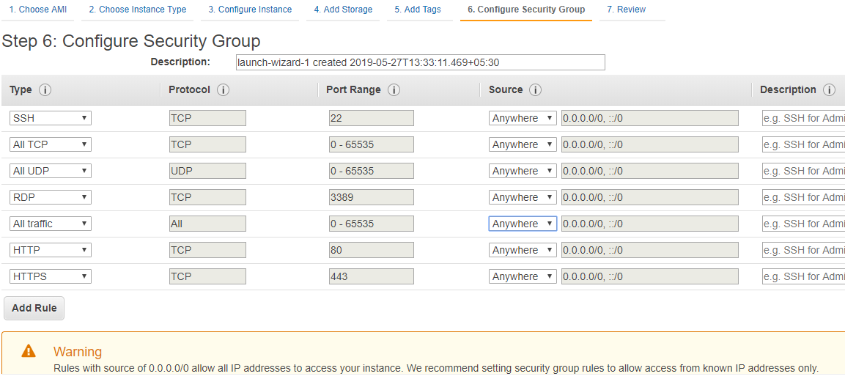

1. Click on “**Review and Launch**” button –

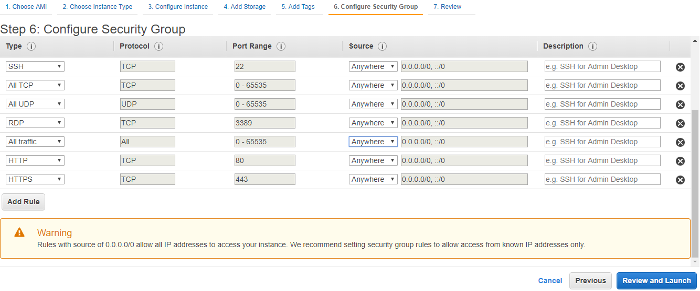

1. On the “Review” page, scroll down and click “**Launch**” button –

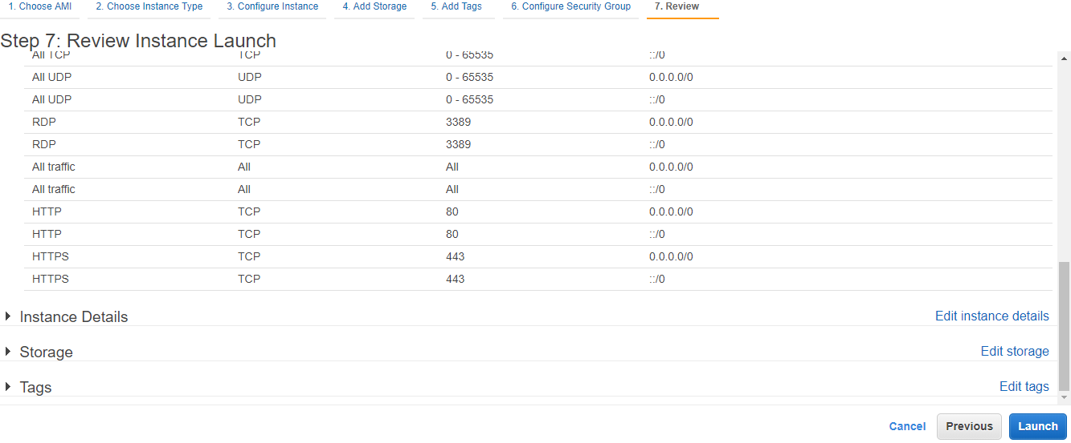

1. One “**Key-Pair**” popup will be launched –

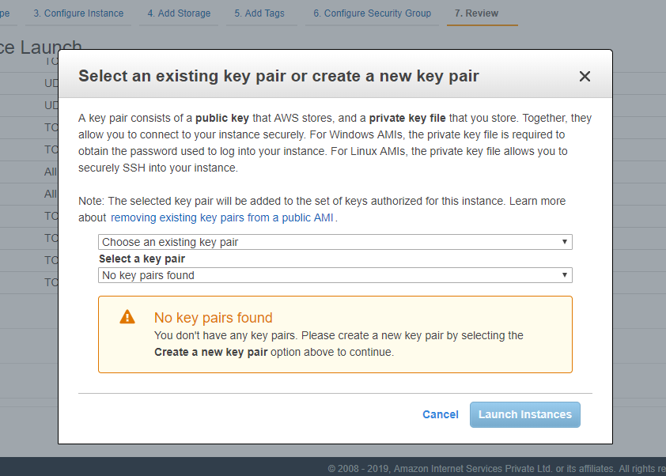

1. Open the first drop-down and select “**Create a new key pair**” from the list.

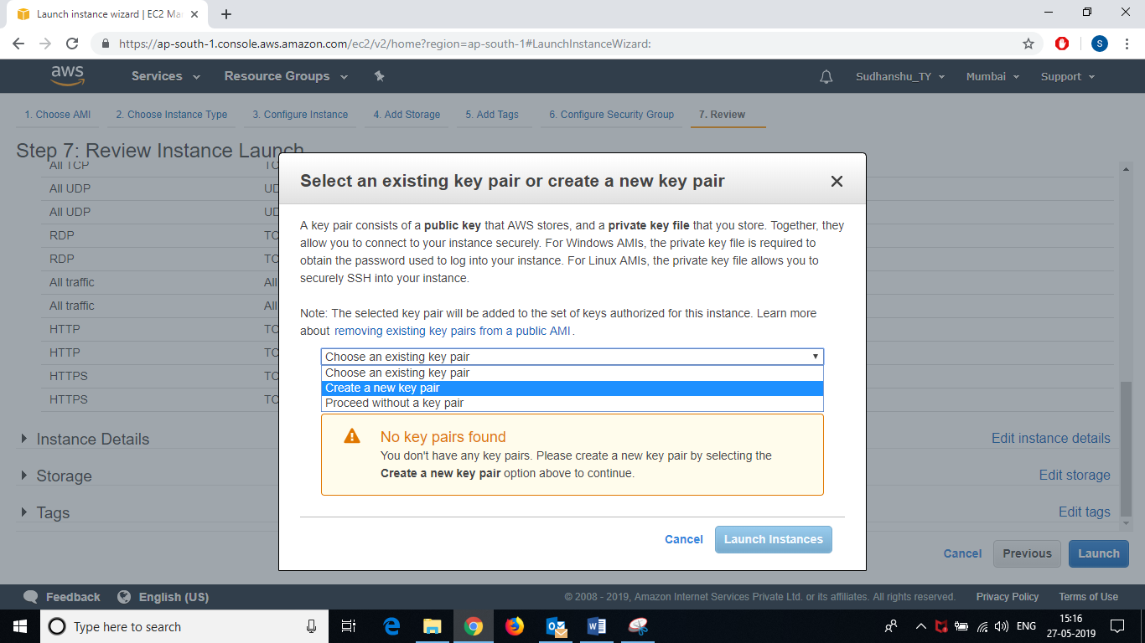

1. Enter “**Key Pair Name**” as –  
    **webserver_ubuntu_key**

* Click on “**Download Key Pair**” button

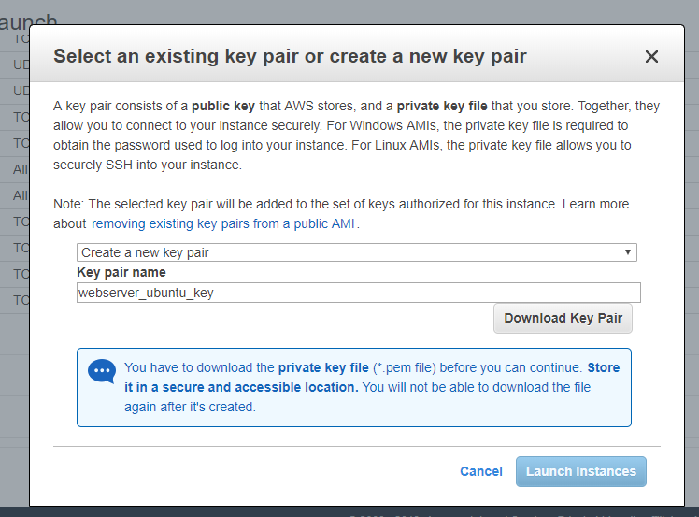

* It will download the “**webserver_ubuntu_key.pem**” file. Save this “.pem” file ***(we need this file in future to connect to this instance using PuTTY)*.**

**[NOTE: - This “.pem” file is an important file. It will be required in future as well. So, save this file in a place u can easily remember and also in the drive other than your OS installed drive.]**

1. Click on “**Launch Instances**” button.

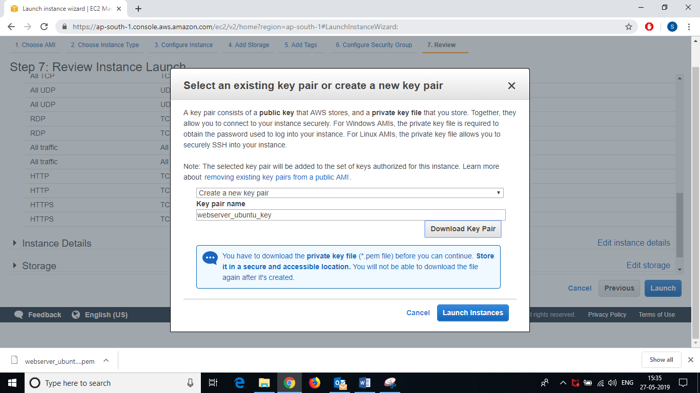

“**.pem**” file will be downloaded when u click on “*download key pair*” button (in previous step-18)

1. The ‘**Launch Status**’ page will be displayed.

* Click on your **instance link.** Link will be present inside *“Your instances are now launching”* box after *“The following instance launches have been initiated:”* message.

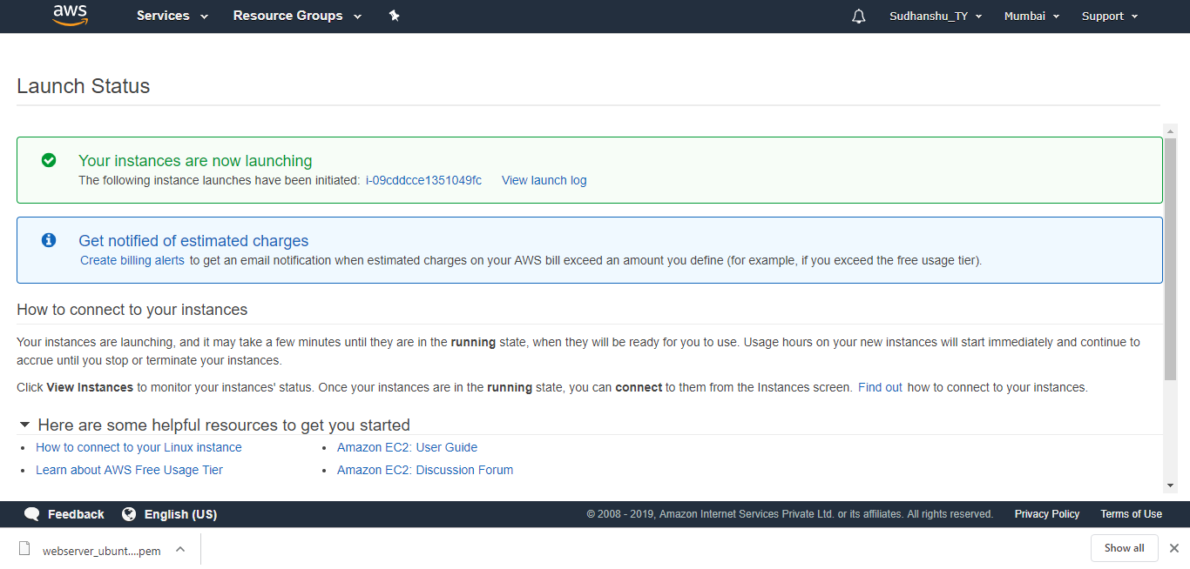

1. Hover the mouse on the “**Name”** field of the instance and click on **pensil / edit icon.**

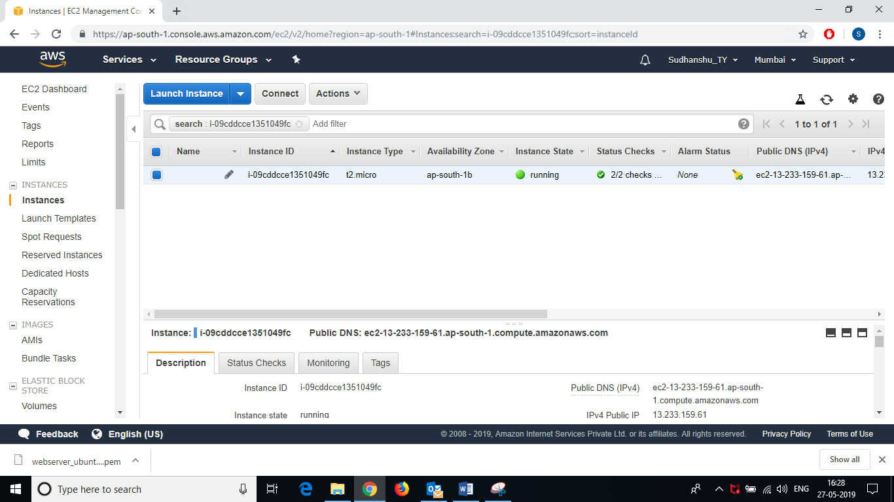

* Give some **name** to your instance (ex. - awsUbuntuWS) and press Enter or click on mark.

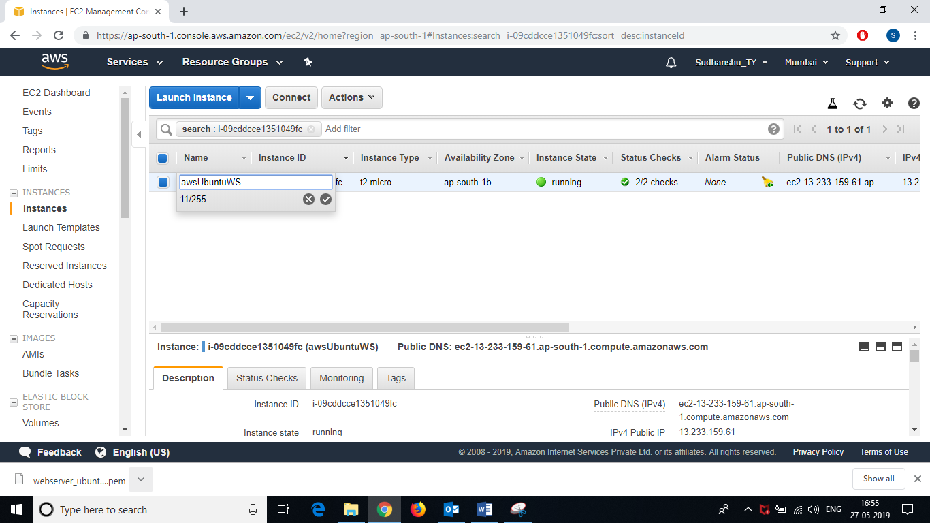

1. Check value of “**Status Check**” column. if it is *“****initializing****”*, wait for some time until it gets initialized. When initialization of your instance is completed, the value or “**Status Check**” column will be like “***2/2 checks passed***”.

* ***Let the initialization complete.***

1. Now, **Create your own “Elastic IP”** –
   1. Scroll down the left hand side navigation pane, under “**Network & Security**” click on “**Elastic IPs**”

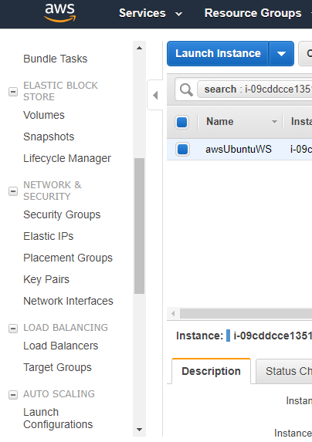

* 1. Click on “**Allocate new address**” button

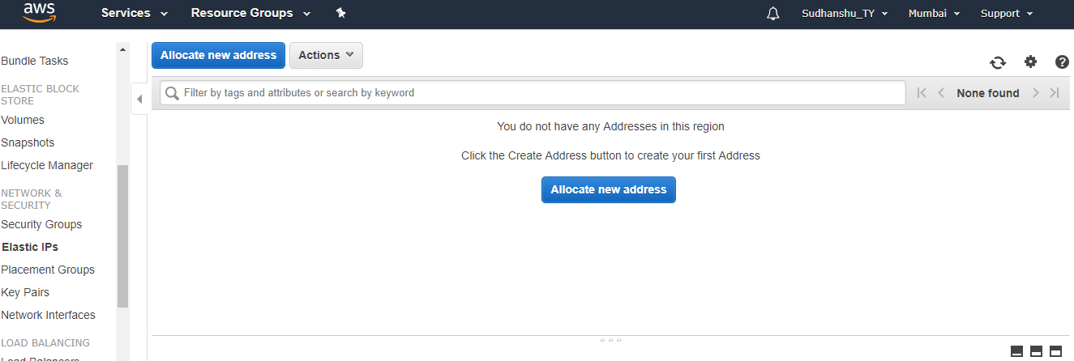

* 1. Click on “**Allocate**” button –

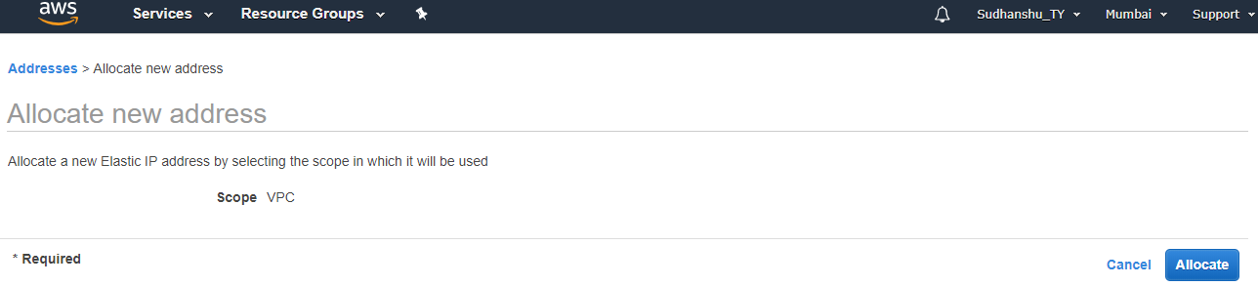

* 1. New IP will be allocated. Click on “**Close**” button.

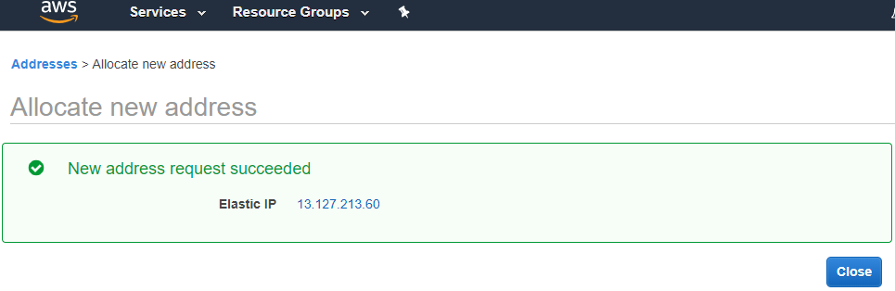

1. **Associate your Private IP with Elastic IP** –
   1. On the left hand side navigation pane, scroll down --> under “**Network & Security**” click on “**Elastic IPs**”

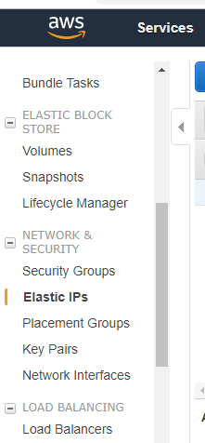

* 1. Click on “**Action**” and select “**Associate Address**”

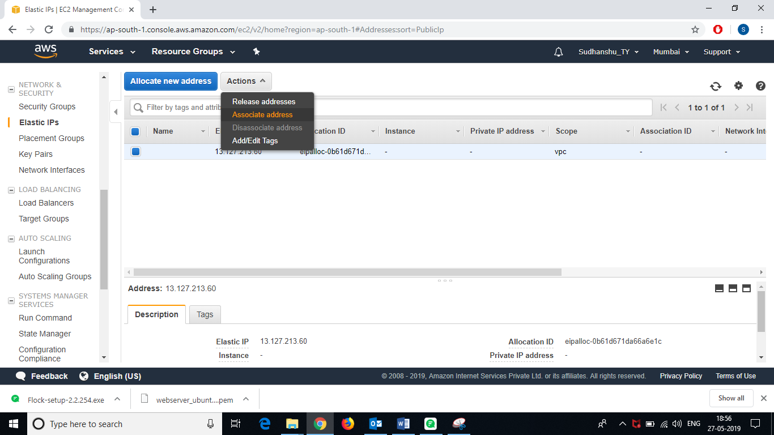

* 1. Select the “**Instance**” radio button against “*Resource Type*”  
     And expand ***Instance*** dropdown and **select your instance**.

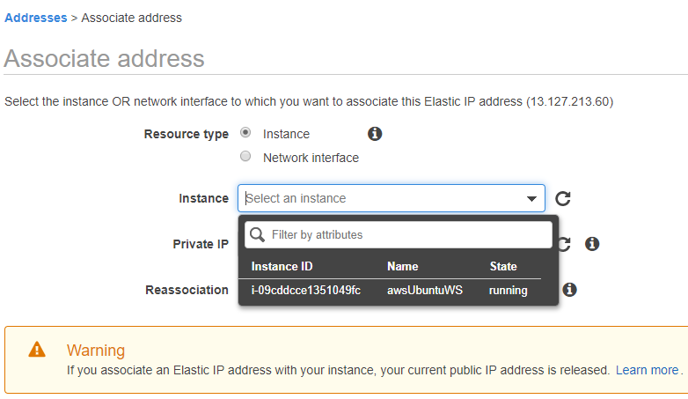

* 1. Expand ***Private IP*** dropdown and **select your Private IP** –

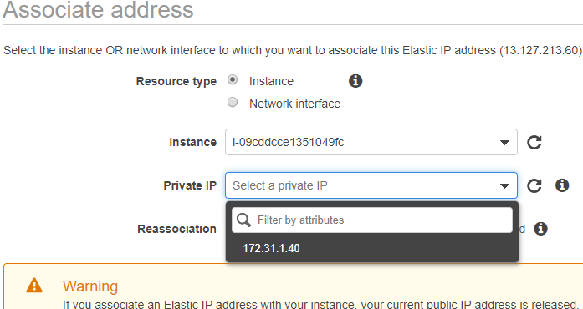

* 1. Click on “**Associate**” button

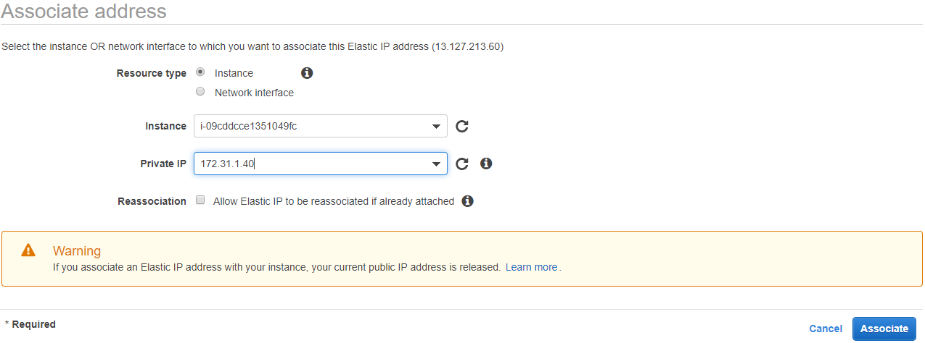

* 1. Click on “**Close**” button –

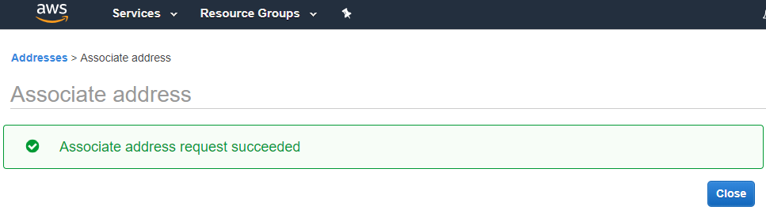

* ***Your EC2 instance is configured now.***
* **Now you can Connect to your EC2 Instance Using PuTTY.   
  [PuTTY** & **PuTTYgen** Software are **required]**

1. Open “**PuTTYgen**” software
   1. select the *‘type of key to generate’* as “**RSA**”

- Click on "**Load** button

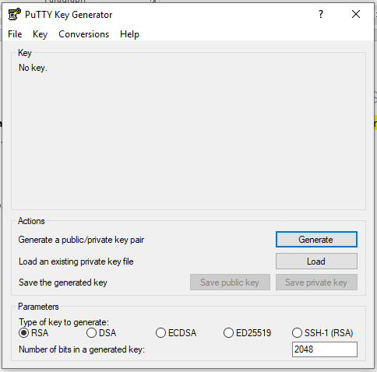

1

2

* 1. Select “**All Types (*.*)**” from file types dropdown –

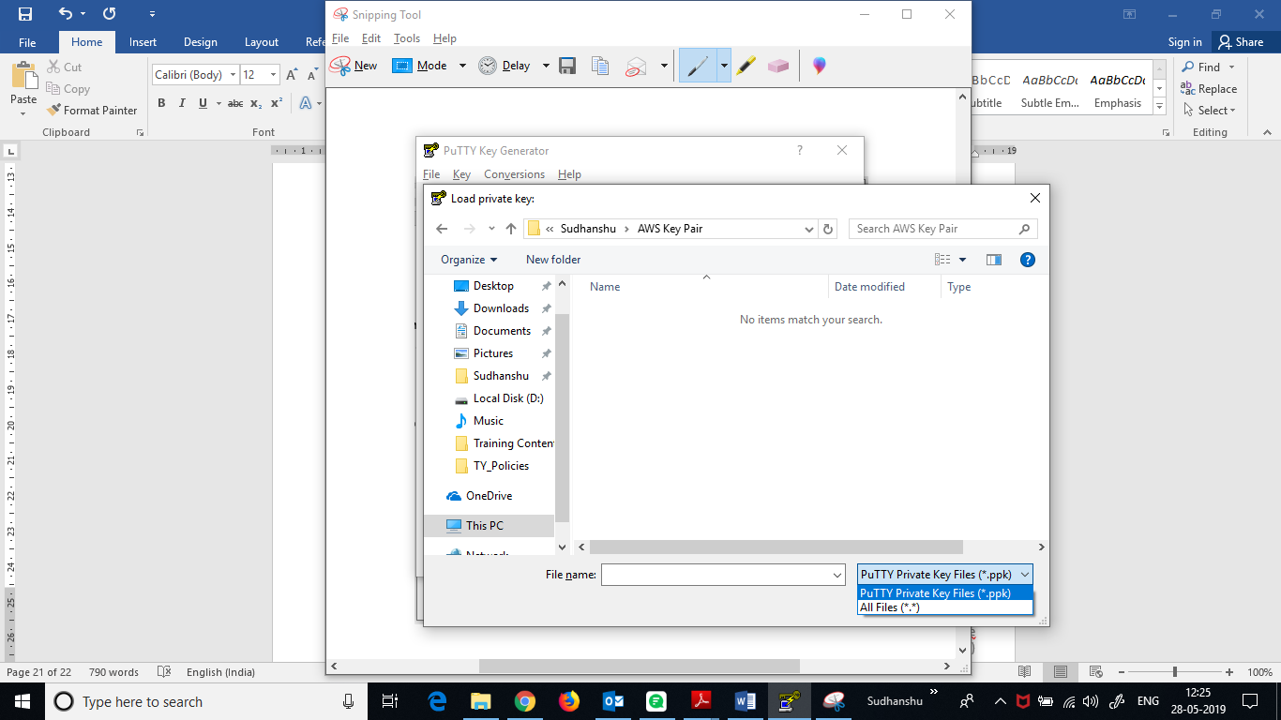

* 1. Browse for “**webserver_ubuntu_key.pem**” file *(downloaded in STEP-* ***18****)*, select it and click on “**Open**” –

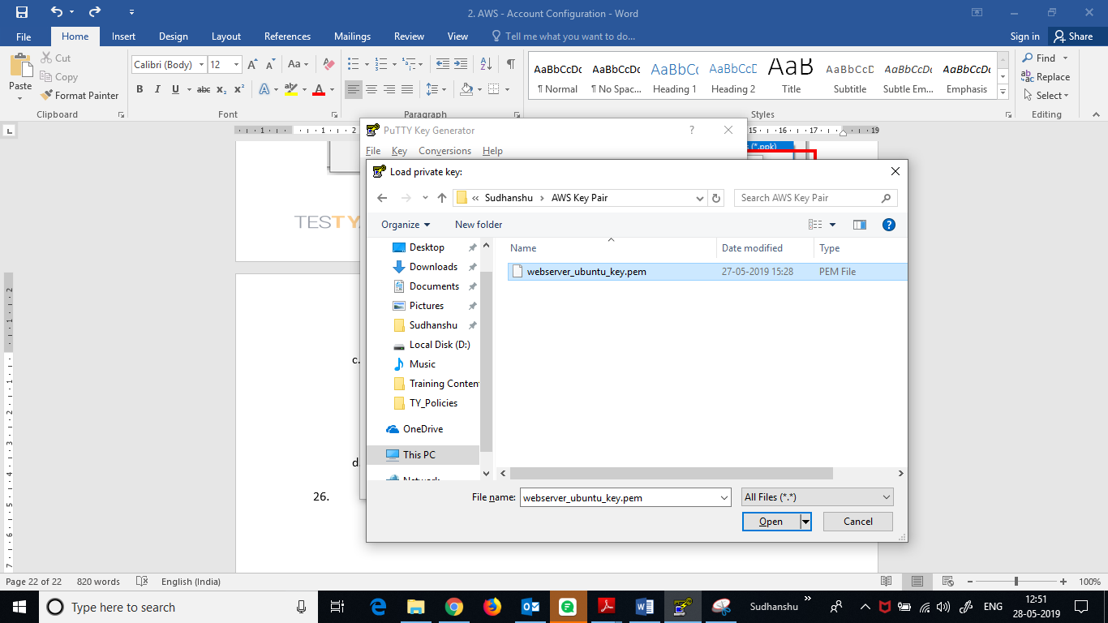

* 1. If “*PuTTYgen Notice*” popup pops up, click on “OK”

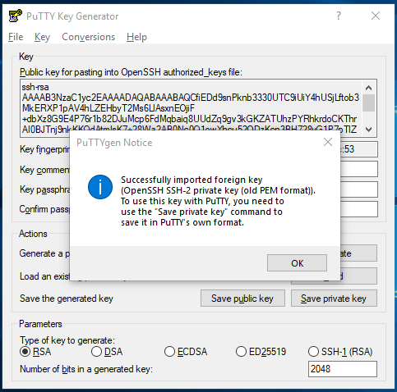

* 1. Click on “**Save private key**” button –

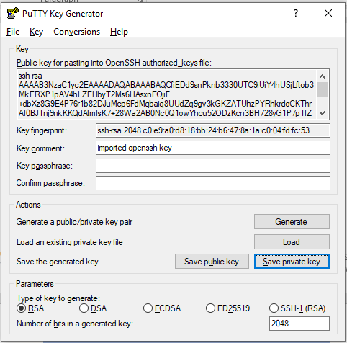

* 1. On ‘*PuTTYgen Warning*’ popup, click on “**Yes**” –

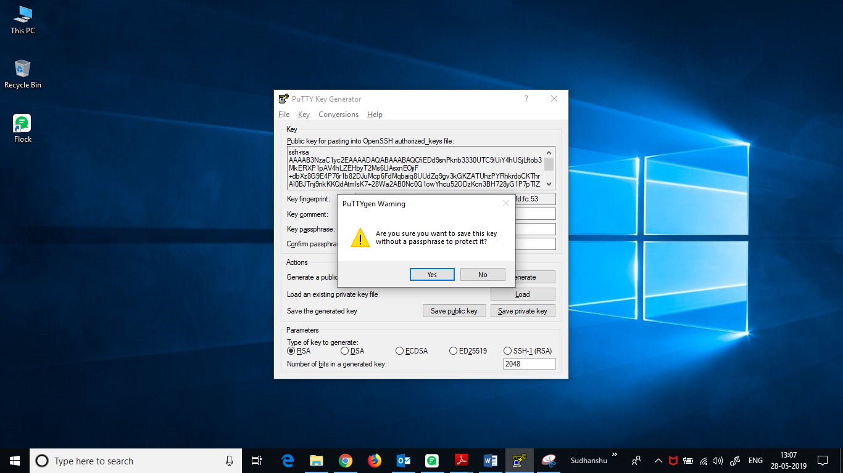

* 1. Save the file by name “**webserver_ubuntu_key**”.  
     (file name with extension will be “**webserver_ubuntu_key.ppk**”)

**[NOTE: - This “.ppk” file is an important file. It is *required to connect to your server (instance)* using PuTTY. So, save this file in a place u can easily remember and also in the drive *other than* your OS installed drive.]**

* 1. **Close** PuTTYgen.

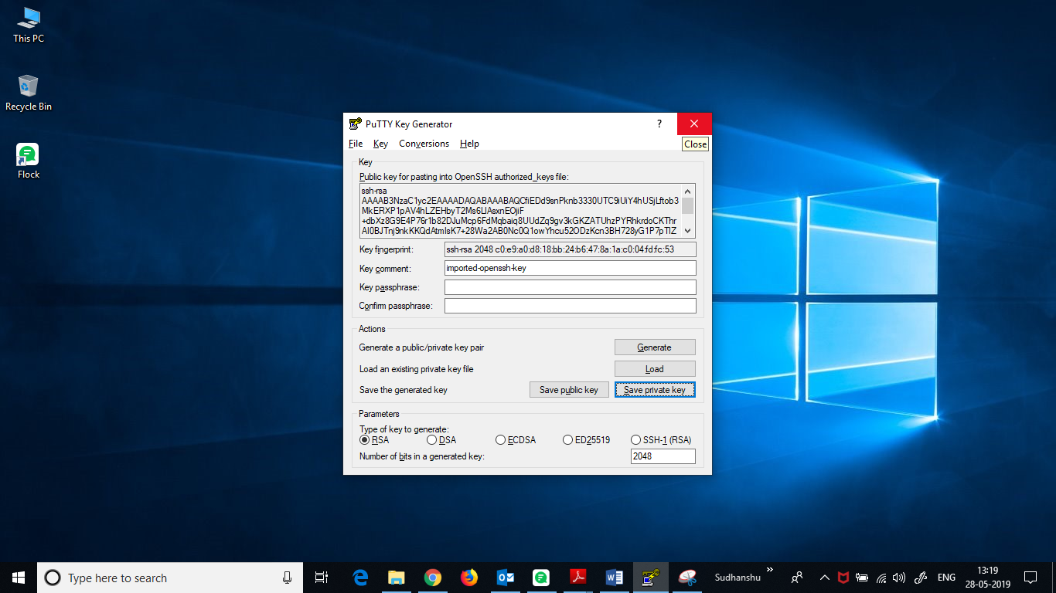

1. Open “**PuTTY**” software.

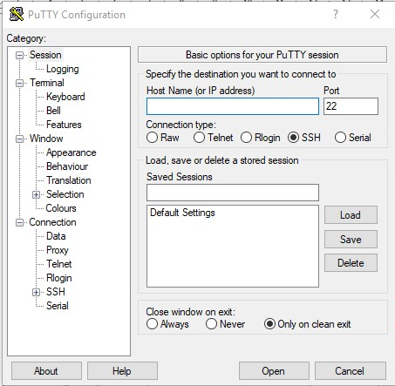

‘Host Name’ can be found in *‘EC2 – Dashboard’* of AWS.

**(Follow Below Steps)**

* 1. Here you need to Enter the **Host Name**. *To find host name, proceed as follows –*
* Login to you AWS Management Console, and go to your **EC2 Dashboard**.  
  (Follow STEP - **1** - **3**)
* Click on “**Running Instances**”

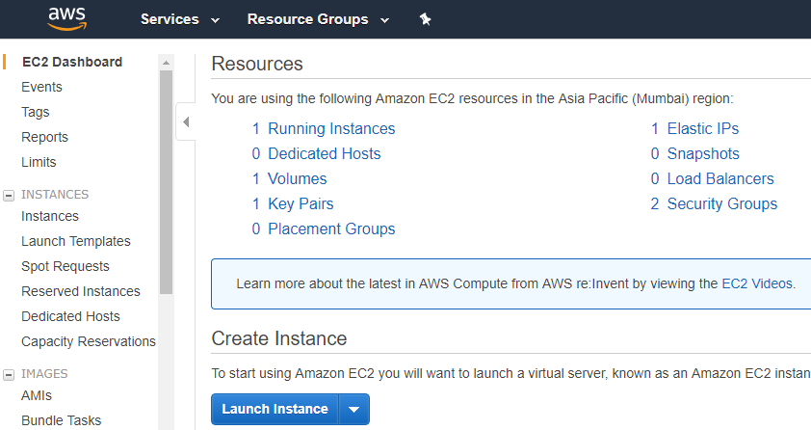

* **Select** Your ‘***EC2 Instance***’ with which you want to connect –

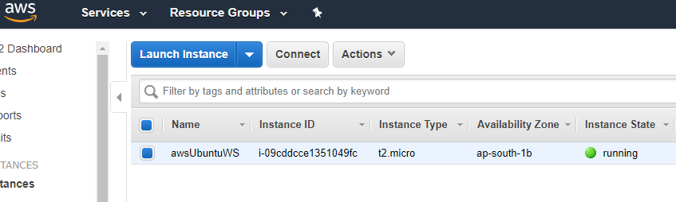

* Click on “**Connect**” button –



* Copy the **URL** *(this will be the host name in PuTTY)* –

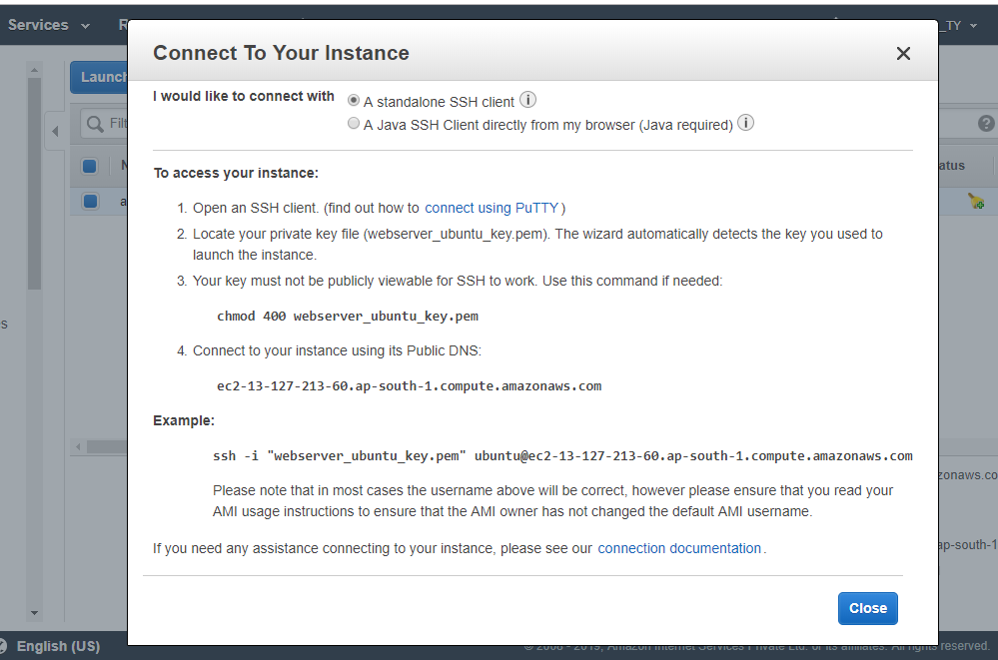

* Go back to PuTTY.
  1. Paste the copied URL in **Host Name** input box –

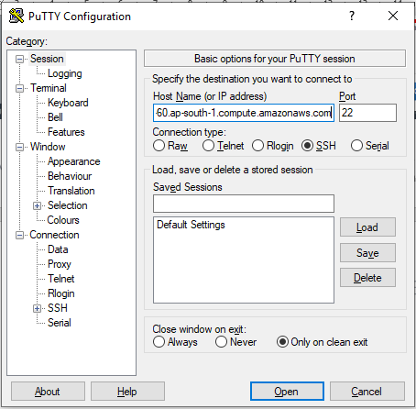

* 1. Enter *“Port no”* **22** and select *‘Connection Type’* “**SSH**”



* 1. Under “**Category:**” Navigation Pane, Expand **Connection** 🡪 **SSH** 🡪 select “**Auth”**

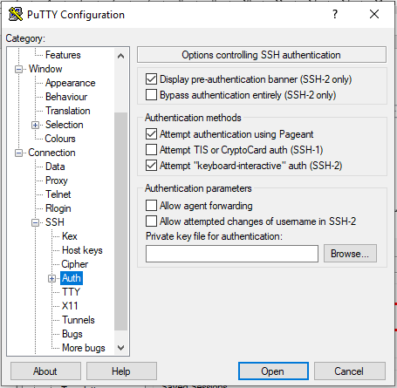

* 1. **Ensure** the checkboxes checked as in below image and click on “**Browse**” button –



* 1. Browse for “**webserver_ubuntu_key.ppk**” file *(generated and saved in STEP-* ***25.g****)*, select it and click on “**Open**” –

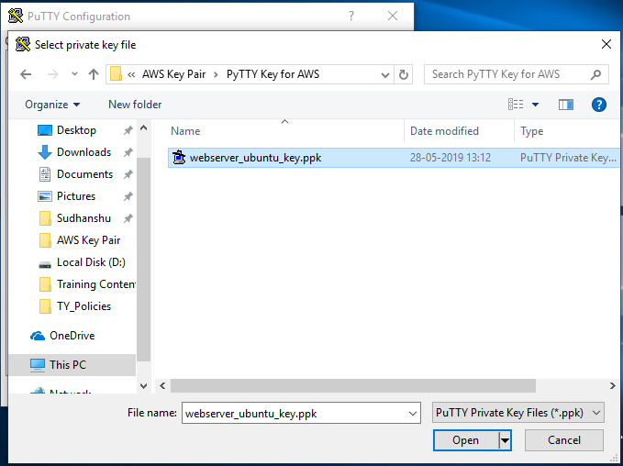

* 1. Click on “**Open**” –

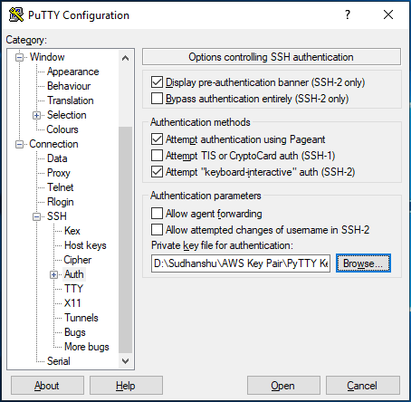

* 1. In the “*PuTTY Security Alert*” dialogue box, click on “**Yes**” button –

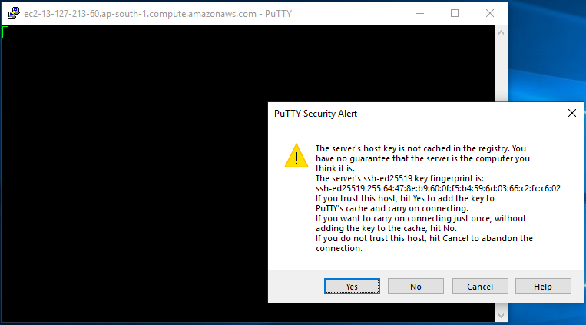

* 1. 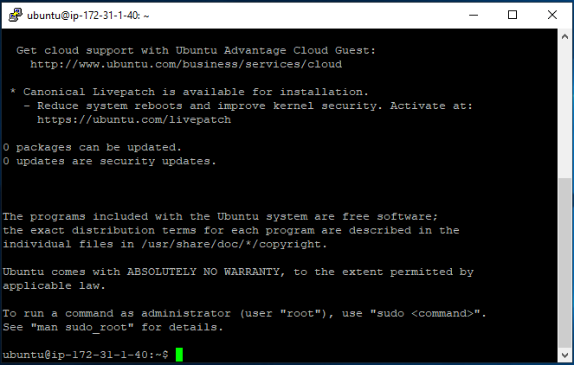That’s it. You are now in your Server (EC2 - Instance).